Dactyl

🔹 What is Dactyl
# Source: AI Source: Provided by: [Data Path: Persons Table -> ID Column: 1, Name_En Column: Motasem Essam] -> From: [Chatgpt (GPT-4-turbo)] on [8/3/2025]
A dactyl is a metrical foot consisting of three syllables:
- The first syllable is stressed, followed by two unstressed syllables:
— ◡ ◡
This creates a falling, rolling, or tumbling rhythm—the opposite of an anapest.

✅ Syllable Pattern:
# Source: AI Source: Provided by: [Data Path: Persons Table -> ID Column: 1, Name_En Column: Motasem Essam] -> From: [Chatgpt (GPT-4-turbo)] on [8/3/2025]
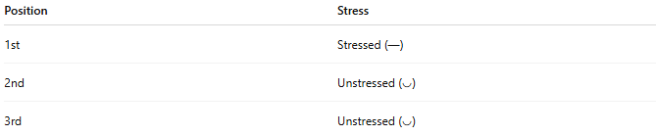
Position | Stress
1st | Stressed (—)
2nd | Unstressed (◡)
3rd | Unstressed (◡)

✅ Examples of Dactylic Words or Phrases:
# Source: AI Source: Provided by: [Data Path: Persons Table -> ID Column: 1, Name_En Column: Motasem Essam] -> From: [Chatgpt (GPT-4-turbo)] on [8/3/2025]
- MERrily
- ELegant
- BIcycle
- SUDdenly
- HAPpiness
Each starts with a stressed syllable followed by two lighter ones.

✅ Function in Poetry:
# Source: AI Source: Provided by: [Data Path: Persons Table -> ID Column: 1, Name_En Column: Motasem Essam] -> From: [Chatgpt (GPT-4-turbo)] on [8/3/2025]
Dactyls are used for a falling rhythm and often convey:
- Urgency, grandeur, or melancholy
- Found in classical poetry (especially dactylic hexameter) and narrative verse

✅ Famous Example – Dactylic Hexameter:
# Source: AI Source: Provided by: [Data Path: Persons Table -> ID Column: 1, Name_En Column: Motasem Essam] -> From: [Chatgpt (GPT-4-turbo)] on [8/3/2025]
From classical epic poetry (e.g., Homer, Virgil):
Arma virumque canō, Trōiae quī prīmus ab ōris...
(Opening line of The Aeneid by Virgil)
Although originally in Latin, this meter was often rendered in English imitation using dactylic hexameter: six feet per line, often five dactyls + one spondee.

✅ Dactylic Example in English (modified):
# Source: AI Source: Provided by: [Data Path: Persons Table -> ID Column: 1, Name_En Column: Motasem Essam] -> From: [Chatgpt (GPT-4-turbo)] on [8/3/2025]
CANon in D / ECHOes through / VALleys and / WHISPering / WIND over / GRASS
Each of the first five feet is a dactyl (— ◡ ◡), and the last foot is usually a spondee or trochee in hexameter.

✅ Contrast with Other Metrical Feet:
# Source: AI Source: Provided by: [Data Path: Persons Table -> ID Column: 1, Name_En Column: Motasem Essam] -> From: [Chatgpt (GPT-4-turbo)] on [8/3/2025]
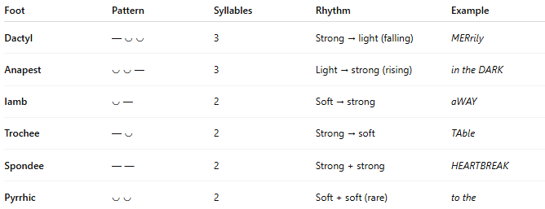
Foot | Pattern | Syllables | Rhythm | Example
Dactyl | — ◡ ◡ | 3 | Strong → light (falling) | MERrily
Anapest | ◡ ◡ — | 3 | Light → strong (rising) | in the DARK
Iamb | ◡ — | 2 | Soft → strong | aWAY
Trochee | — ◡ | 2 | Strong → soft | TAble
Spondee | — — | 2 | Strong + strong | HEARTBREAK
Pyrrhic | ◡ ◡ | 2 | Soft + soft (rare) | to the

📝 Summary:
# Source: AI Source: Provided by: [Data Path: Persons Table -> ID Column: 1, Name_En Column: Motasem Essam] -> From: [Chatgpt (GPT-4-turbo)] on [8/3/2025]
- Dactyl = stressed + two unstressed syllables (— ◡ ◡)
- Produces a rolling, falling rhythm
- Common in dactylic hexameter, especially in classical epic poetry
- Opposite of the anapest

